Figure 1: eternal cure [1]

Level Abstract: Eternal Cure
  - The Elder Scrolls V: Skyrim – Yang Xu
  - Version 2.0
Position Title | Name | Signature
Level Designer | Yang Xu

Designer: | Yang Xu
Document Date: | 11/01/2015
Intended Level Delivery Date: | 12/15/2015

Document Revisions Table
Version | Description | Requestor | Date
0.1 | Initial document with brief draft | Professor | 11/01/2015
0.3 | Updated Level Map in document | Professor | 11/02/2015
0.7 | Update Level Progression Chart in document | Professor | 11/03/2015
1.0 | Final Document | Professor | 11/04/2015
2.0 | Rewrite document, update content, correct errors | Professor | 12/04/2015

Table of Contents
Table of Contents 3
Table of Figures 4
Quick Summary 5
Hook(s) 5
Gameplay Highlights 5
Setting Summary 5
Mission Difficulty 6
Mission Metrics 6
Characters 6
Visual Themes 7
Key Theme References 7
Level Summary 12
Campaign 12
Context 12
Backstory 12
Aftermath 12
Objective(s) 13
Overview Map 14
Level Flow 17
Flow Summary 17
Level Progression Chart 18
Quest Descriptions 19
Main Quest – “Eternal Cure” 19
Side Quest – “Help from the Ancient” 20
References 21

Table of Figures

Figure 1: eternal cure [1] 1
Figure 2: the house of necromancer, dark magic and decay feeling [2] 7
Figure 3: Druid’s cave, overgrow plants and mysterious feeling [3] 8
Figure 4: Druid’s ritual, colorful plants and vivifying feeling [4] 8
Figure 5: Druid’s cave entrance, mysterious and ancient feeling [5] 9
Figure 6: village ruins, lifeless feeling [6] 9
Figure 7: dead forest, lifeless feeling [7] 10
Figure 8: dead forest winter, lifeless feeling [8] 10
Figure 9: necromancer cave, dark magic and bloody feeling [9] 11
Figure 10: necromancer cave far, dark magic and bloody feeling [10] 11
Figure 11: Azuel’s shanty 14
Figure 12: path under water concept 14
Figure 13: path under water screenshot 14
Figure 14: Druid’s cave top view (with second floor) 15
Figure 15: Druid's cave top view (hide second floor) 15
Figure 16: Druid's cave side view 16
Figure 17: the jump short cut lead the player back to main room (concept) 16
Figure 18: jump short cut screenshot 16
Figure 19: level progression chart 18

Level Abstract

Quick Summary
“Eternal Cure” is a single player (SP) level in The Elder Scrolls V: Skyrim. The quest is about love, decision and sacrifice. A stranger anxiously looks for help near the Riverwood Bridge. His beloved daughter suffers from an incurable disease. The father believes his research on a forbidden spell could be the only hope for his daughter. However, to use this spell, he needs the help to acquire the soul of an elder Druid. Player finds the Druid’s cave with the father’s direction. While facing the Druid, he shows player a fact that he already knows everything about the father, the daughter and the player. He tells player a prophecy that the father would use his spell against the world after he finishes it. The Druid asks player to help him stop the father from finishing his spell, which may destroy the only hope for the little girl. The Druid promises to try to save the girl but he is not sure whether he can succeed. Player must decides to kill the Druid or help him, which leads to two different endings. Save a dying little girl or trust the mysterious prophecy of a stranger? Player must use their best judgment to make the decision.

Hook(s)
- The difficult decision that affects player deeply
- The unique weapon/spell book reward
- The unique dungeon of the Druid

Gameplay Highlights
- Two story branches
  - Help the father and sacrifice the Druid to save the daughter
  - Help the Druid to stop the father and destroy the spell
- Maze challenge based on riddles, player answers them to go through the maze.
- Dodge challenge based on traps, enemy spawns if player triggers the trap.
- Combat challenge based on powerful enemies, player needs to show their strength to get through the trial.

Setting Summary
Theme | Decaying, lifeless and mysterious
Mood | Medium intense in combat, medium difficulty for riddles and puzzles
Setting | Skyrim era, mysterious valley with cavernous dungeon (exterior), cavernous dungeon of the Druid (interior)
Time of Day | Skyrim default time
Season | Skyrim default season
Weather | Skyrim default weather

Mission Difficulty
Position | Difficulty | Reasons
Beginning (Azuel’s shanty) | 2 | The initial part of the quest primarily involves talking to the NPC and going to places, the difficulty level is relatively low since there are no combat, puzzles or riddles. Player only needs the basic game control skills to finish this part successfully.
Middle (Druid’s cave) | 5 | The middle part involves a small amount of combat, medium amount of traps and riddles. Player needs basic combat skills along with additional logical skills for the riddles.
End (Natur’s place/Azuel’s shanty) | 6 | The final part is more difficult because of the boss fight. No matter which branch player chooses, there is always a slightly tough boss fight. Player needs advanced combat skills like weapon switching or magic spells.
Scale: 1-10 (1 is Easiest and 10 is Hardest)

Mission Metrics
Play Time | 10-15 minutes depending on player experience
Critical Path | 250x200 Skyrim unit/4 Skyrim Cells (~2200 ft)
Physical Area | 650x300 Skyrim unit/6 Skyrim Cells (~320,000 ft)

Characters
Character | Description
Player | The player is the Dragonborn in the Skyrim world.
Azuel Fabrith | Azuel is a former Archmage of Winterhold College and a father willing to do anything to save his daughter. The college exiles him for his research in forbidden magic. However, Azuel believes his spell is the only hope for his daughter. He is willing to pay any price to finish his spell and save his beloved daughter.
Mabel Fabrith | Mabel is a ten-year-old daughter of Azuel Fabrith. She suffers from an incurable disease and gets weaker every day. She spends most of her time unconscious in bed at the shanty.
Natur the Elder | Natur is a Druid that can see into the future. He sees the cursed future caused by Azuel’s spell and wants to correct it. He waits for the adventurer that is helping the Azuel. He wishes to convince the adventurer to help him and destroy the Azuel’s spell.
Wolf Spirit | Dangerous spirits in the trap trial of the Druid’s cave
Saber Cat Spirit | Dangerous spirits in the combat trial of the Druid’s cave
Bandits | Scoundrels who followed Azuel into the mysterious valley. They burned down Azuel’s house and robbed his chest, which contains an important spell book.

Visual Themes
Theme | Description
Azuel’s shanty: Cloudy, desperate, lifeless, dying temporary | The main color combination is grey, black and white. The texture looks dark, cheap and poor. The lighting of the environment is slightly dark. Use exterior meshes like mountains, dirt and trees.
Druid’s cave: Mysterious, cavernous, wet, misty | The color combination is dark blue, dark green and brown. The lighting is dark. The texture makes those ancient plants and rock stand out. Use interior meshes that relates to caves.
Natur’s place: Mysterious, vivifying, magical, peaceful | The color combination is bright blue, dark green and dark blue. The environment lighting is dark but enough to see things clearly. The texture makes the plants and flowers stand out. Use interior meshes that relates to caves.

Key Theme References
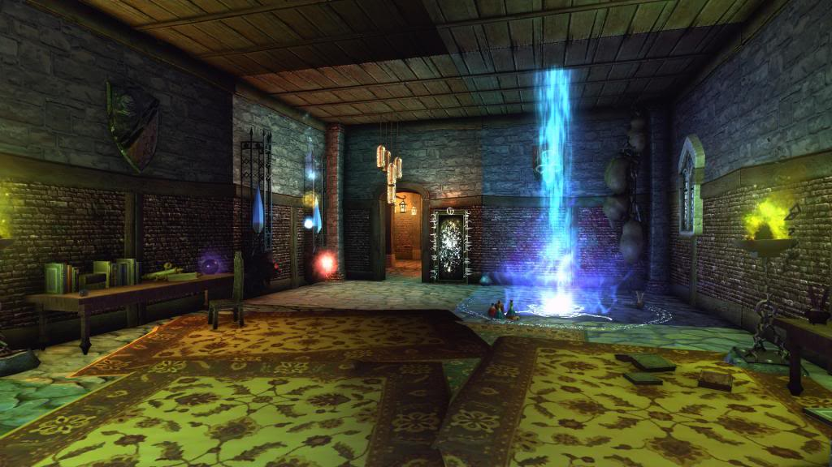
Figure 2: the house of necromancer, dark magic and decay feeling [2]
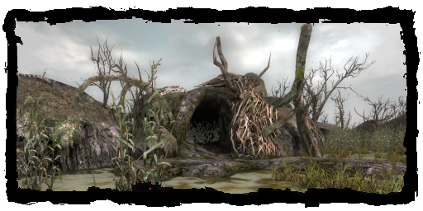
Figure 3: Druid’s cave, overgrow plants and mysterious feeling [3]
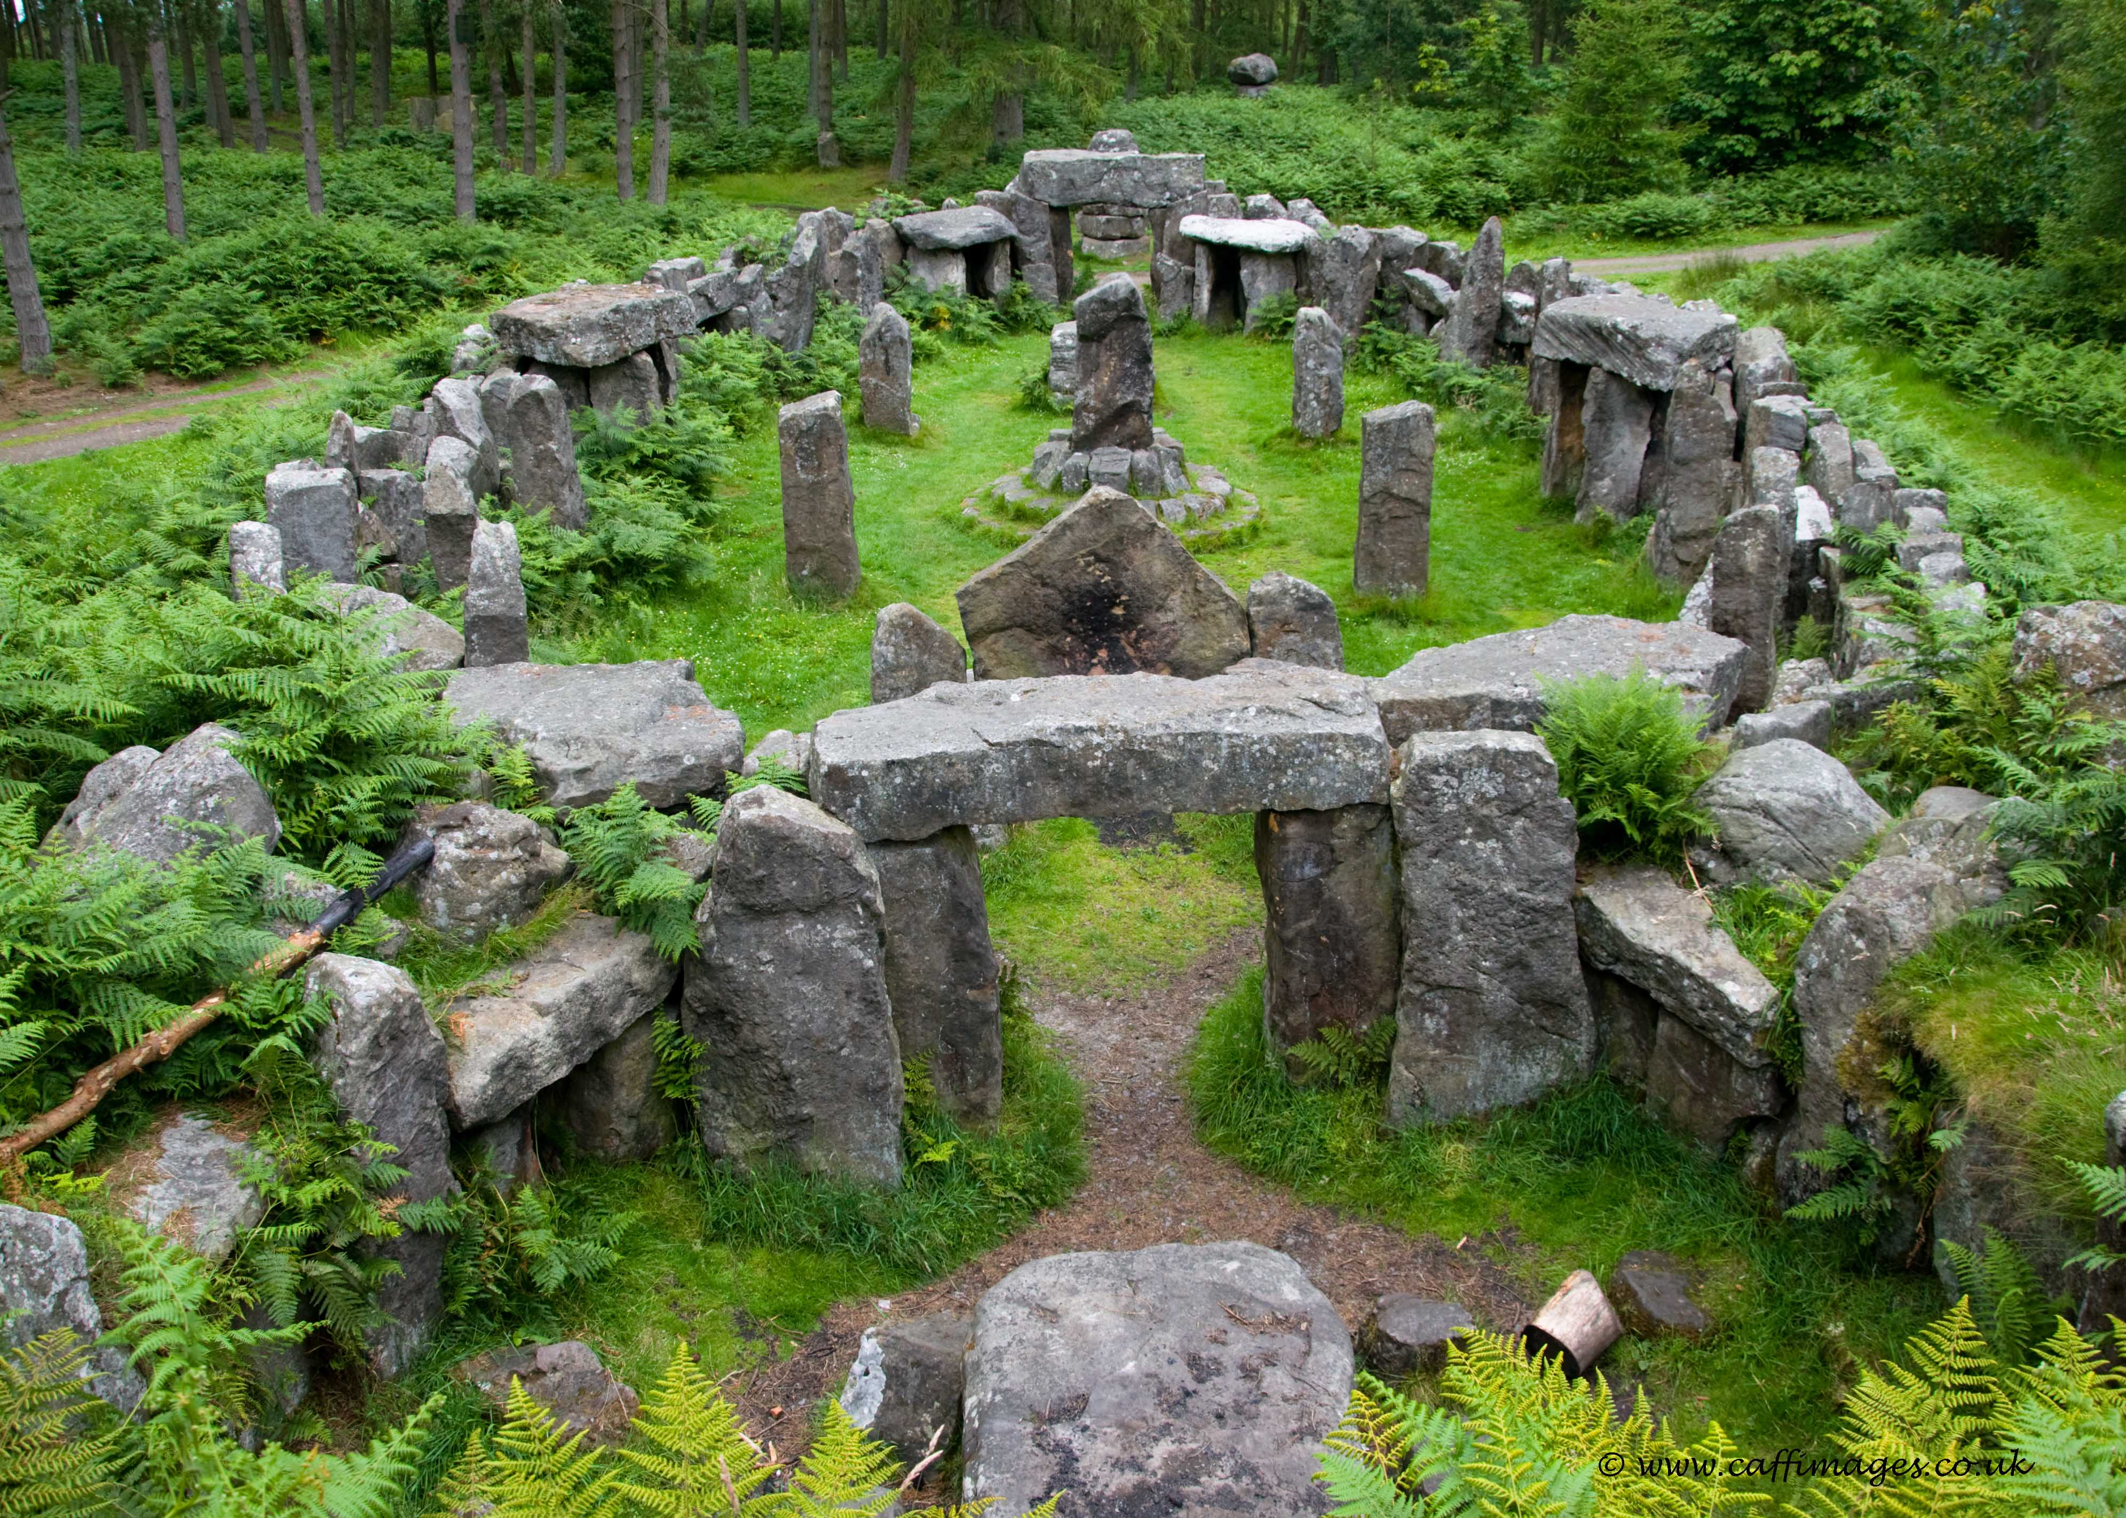
Figure 4: Druid’s ritual, colorful plants and vivifying feeling [4]
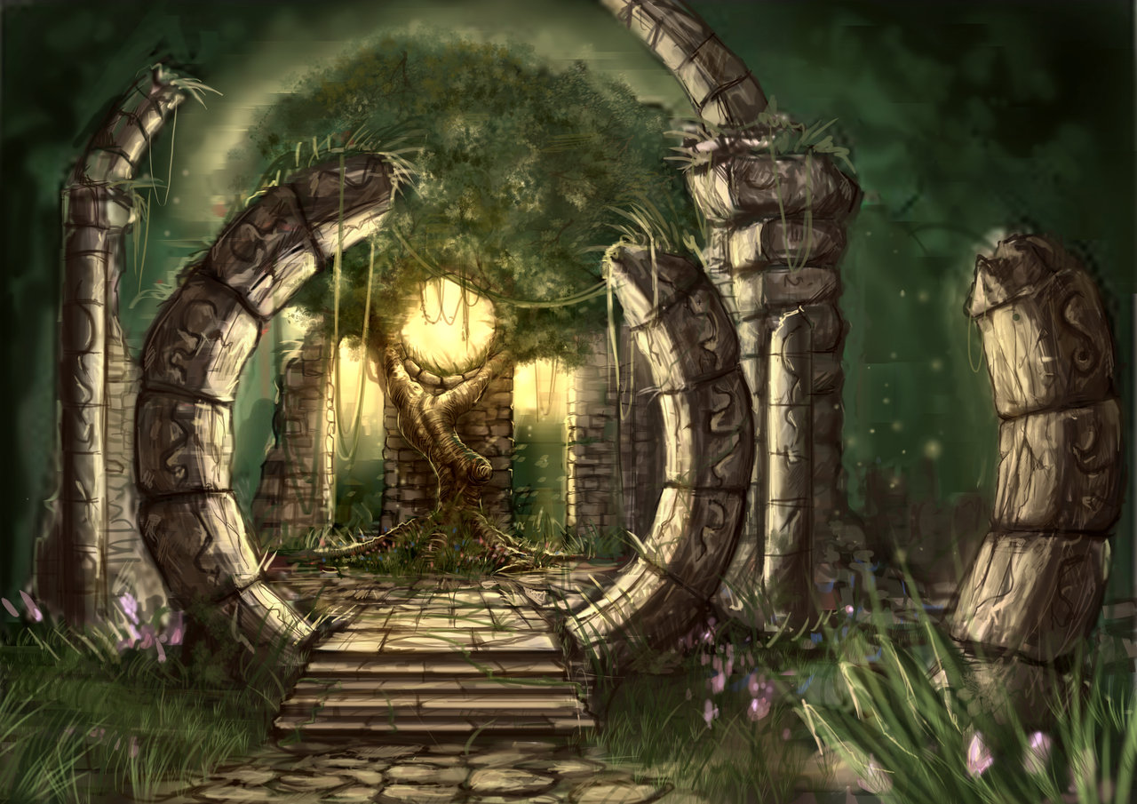
Figure 5: Druid’s cave entrance, mysterious and ancient feeling [5]
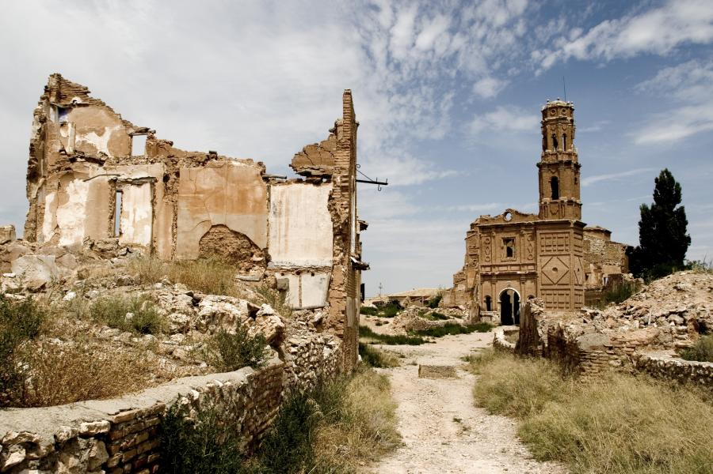
Figure 6: village ruins, lifeless feeling [6]
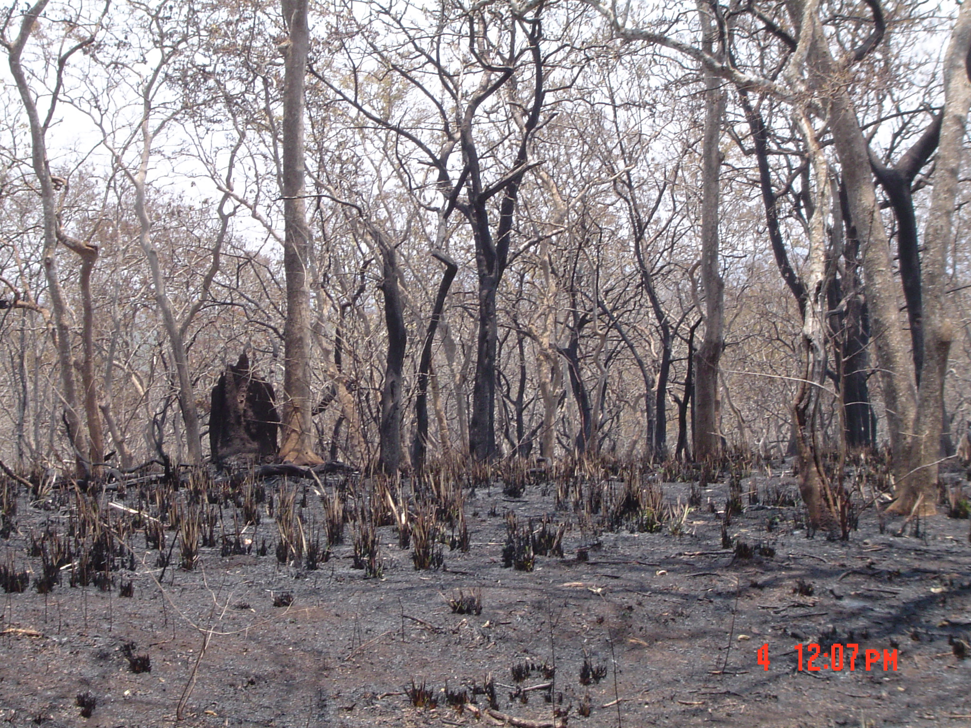
Figure 7: dead forest, lifeless feeling [7]
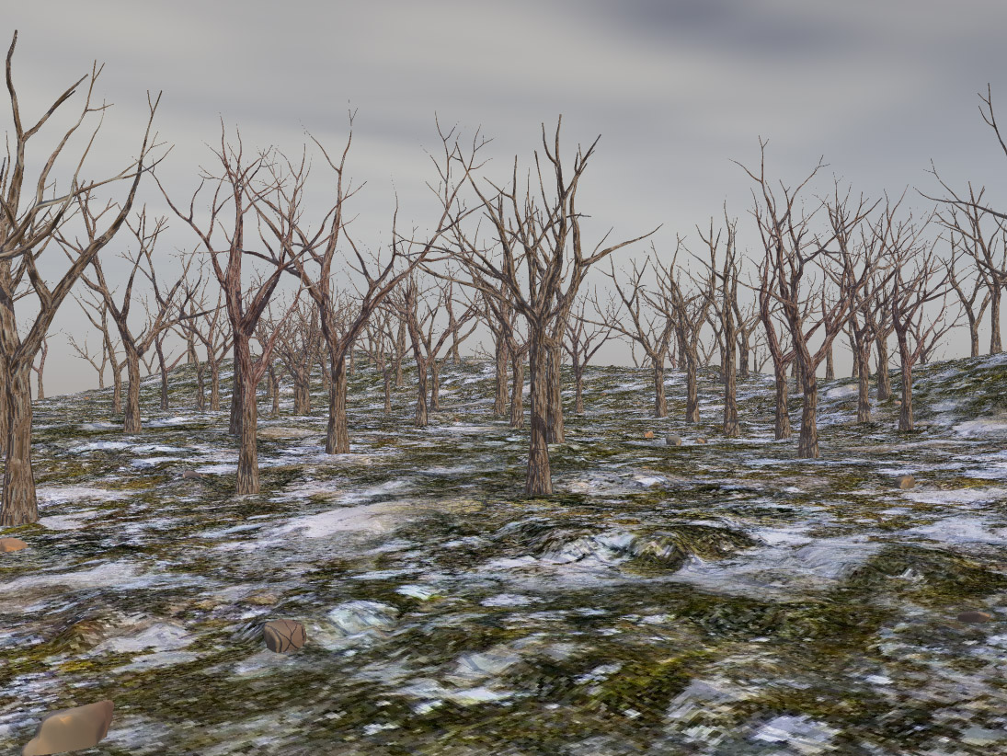
Figure 8: dead forest winter, lifeless feeling [8]
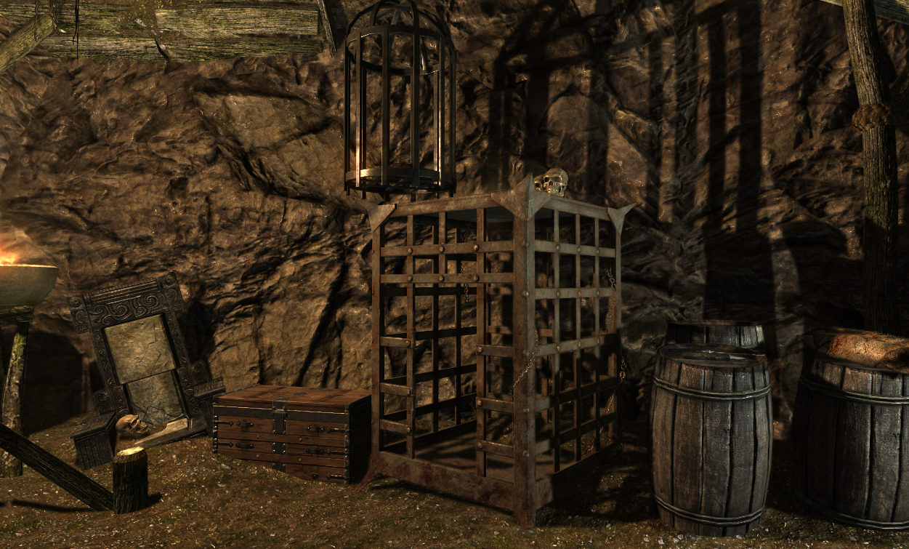
Figure 9: necromancer cave, dark magic and bloody feeling [9]
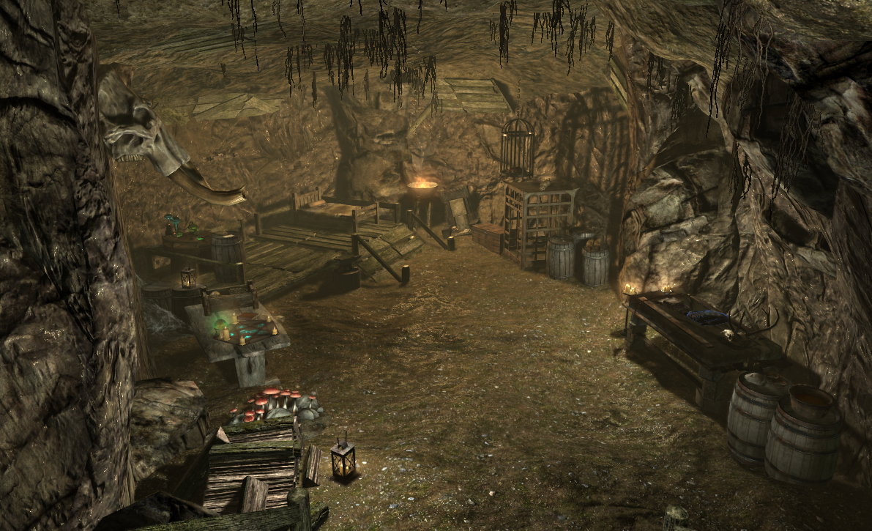
Figure 10: necromancer cave far, dark magic and bloody feeling [10]

Level Summary

Campaign

Context
“Eternal Cure” happens in the middle of the Skyrim story and is a stand-alone mission. The characters involved have the background fit in the Skyrim universe but player has never met them before. The main quest contains one medium interior environment and one huge exterior environment. The quest starts near the Riverwood Bridge and leads player to new places. Player can find map markers for the new places to use fast travel function. “Eternal Cure” contains a main quest and a side quest. Both of them do not connect to other quests in Skyrim. The main quest has two story branches with different endings. The “help Druid” branch has a customized spell reward while the “kill Druid” branch has a customized item reward. The main quest contains combat, traps and riddles. The side quest is linear and contains combat. The reward of side quest is a customized spell book.

Backstory
Azuel Fabrith, a desperate father, seeks help outside of the Riverwood village. His daughter, Mabel Fabrith suffers the incurable disease that consumes her life every day. The only hope for her cure is a new spell invented by Azuel, which is able to turn his daughter into an “undead” but keeps her soul “alive”.
Although he never had the chance to test the spell in Winterhold College, it may be the eternal cure for his beloved daughter if his calculation is right. However, the most important component is a powerful soul. He knows that the mysterious Druid in Skyrim, Natur the elder, is a mighty person with the soul he needs. He manages to locate the Druid’s cave but he cannot go there. Because in that situation he has to leave her daughter alone, which is the last thing he wants to do.
Exiled by the Winterhold for the research of forbidden magic, Azuel has nothing to lose except his Mabel. He puts all his wealth, honor, sanity and morality on this last chance. He has to finish the spell and break nature’s law. However, he needs a mighty adventurer to take down the powerful Druid and bring back his soul stone, the last component of the spell.

Aftermath
The mission ends differently with two branches:
- End 1 - Help Azuel to take down the Druid: Mabel thanks the player and her beloved father. Although it feels strange, she is happy that diseases can never bother her again, even hunger and tiredness. Azuel promises he shall continue studying on this spell until he frees the human race from the curse of death.
- End 2 - Help Natur to destroy the spell and kill Azuel: After Azuel’s death, Natur promises he shall take care of the little girl and try his best to save her. However, her destination is Mother Nature’s decision.

Objective(s)
- Main quest- “Eternal Cure” – Kill Azuel or Natur:
  - Talk to Azuel Fabrith near the Riverwood Bridge. Player can use map marker to travel.
  - Talk to Azuel to teleport to his shanty when player is ready.
  - Talk to Azuel in his shanty.
  - Locate the Druid’s cave near the shanty. Follow Azuel’s clues.
  - Pass Druid’s maze trials with riddles. Answer the riddles to get to the rune and activate it.
  - Pass Druid’s dodge trials with traps. Get to the rune and activate it.
  - Pass Druid’s combat trials with saber cat spirits. Kill all spirits to get to the rune and activate it.
  - After player activates three, activate the portal and use it to teleport to the Druid’s living place.
  - Talk to Druid, Natur the elder. Get the information.
  - Talk to Natur about the decision:
    - Branch 1: Ignore Natur’s advice, kill him to get his soul stone (quest object)
      - Player must not die
    - Branch 1: Return to Azuel’s shanty with Natur’s soul stone
    - Branch 1: Talk to Azuel for reward and end the quest (customized sword reward)

    - Branch 2: Follow Natur’s advice, go back to Azuel’s shanty with him
    - Branch 2: Talk to Azuel
    - Branch 2: Kill Azuel with Natur. (Natur helps player to make sure the destruction of the spell)
      - Player must not die
    - Branch 2: Talk to Natur for reward and end the quest (customized spell reward)

- Side quest – “Help from the Ancient”:
  - Talk to Anzuel to start the quest
  - Locate the bandits near Azuel’s shanty
  - Kill the bandit chief and get the magic key
    - Player must not die
  - Find the secret chest and get the guardian summoning spell book in it (After getting the book, player learns it and the spell helps in the later main quest)

Overview Map
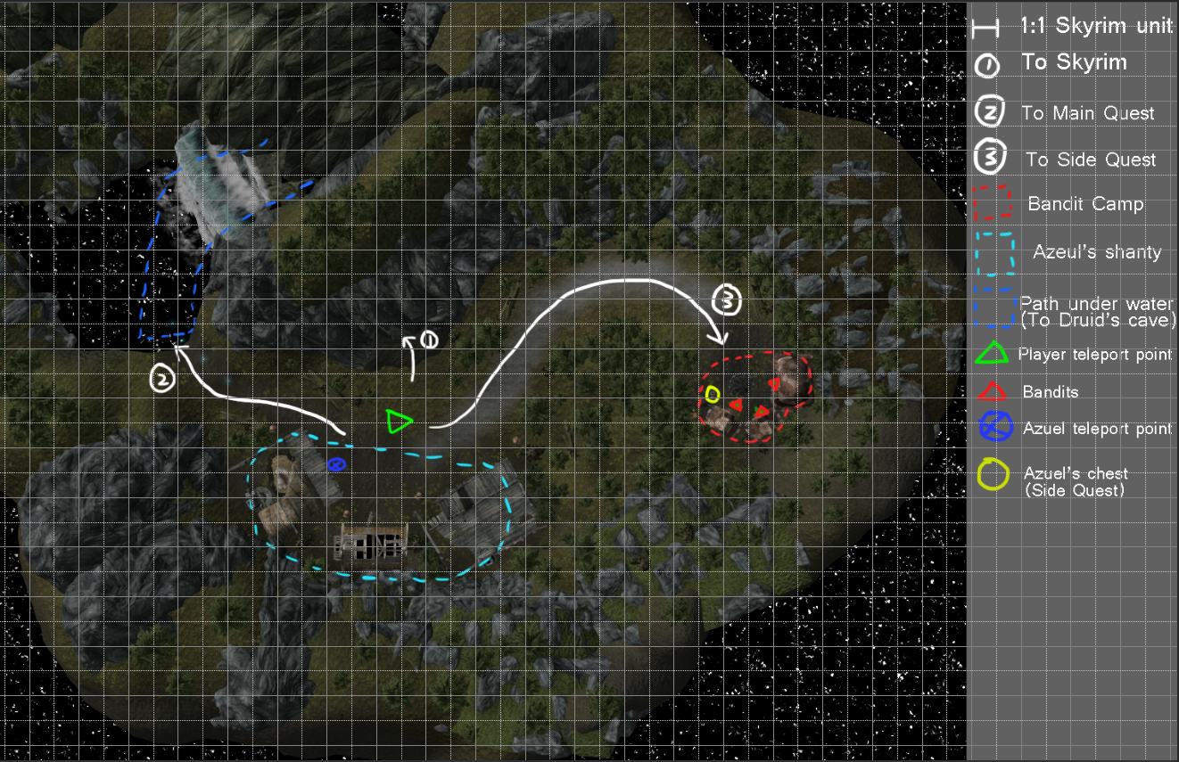
Figure 11: Azuel’s shanty
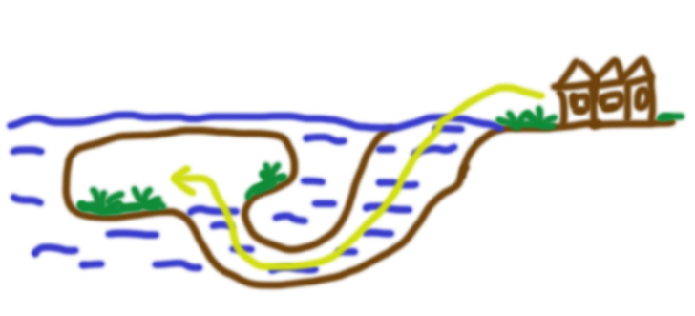
Figure 12: path under water concept
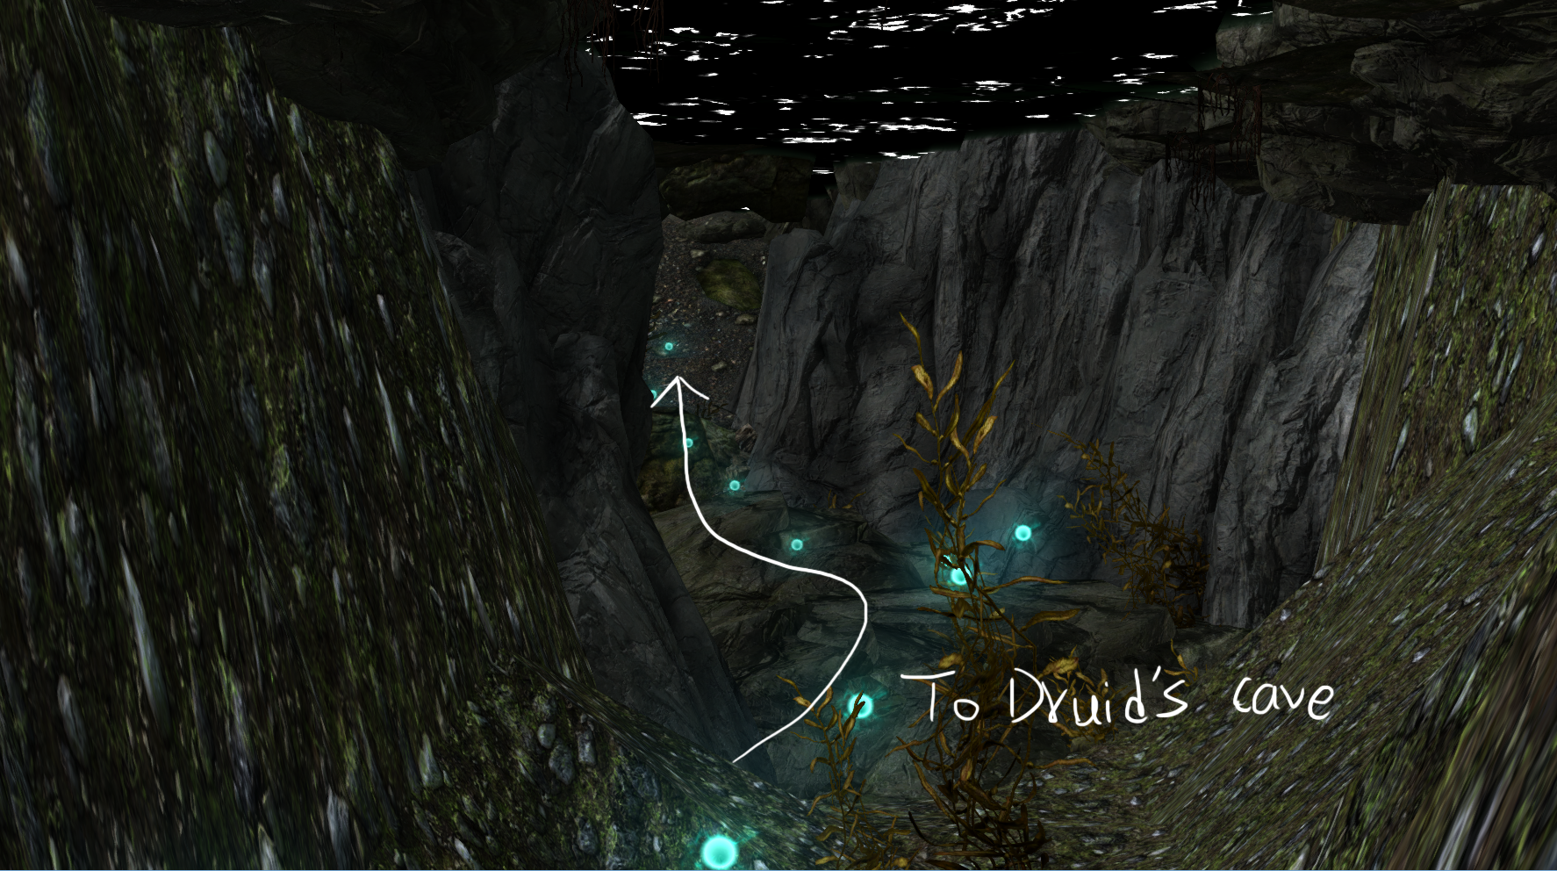
Figure 13: path under water screenshot
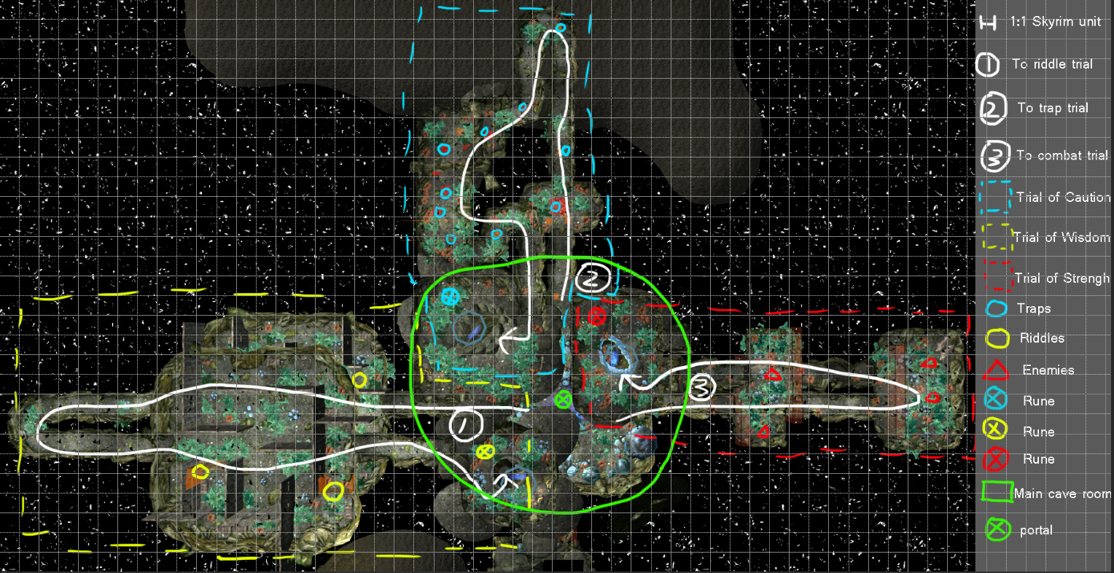
Figure 14: Druid’s cave top view (with second floor)
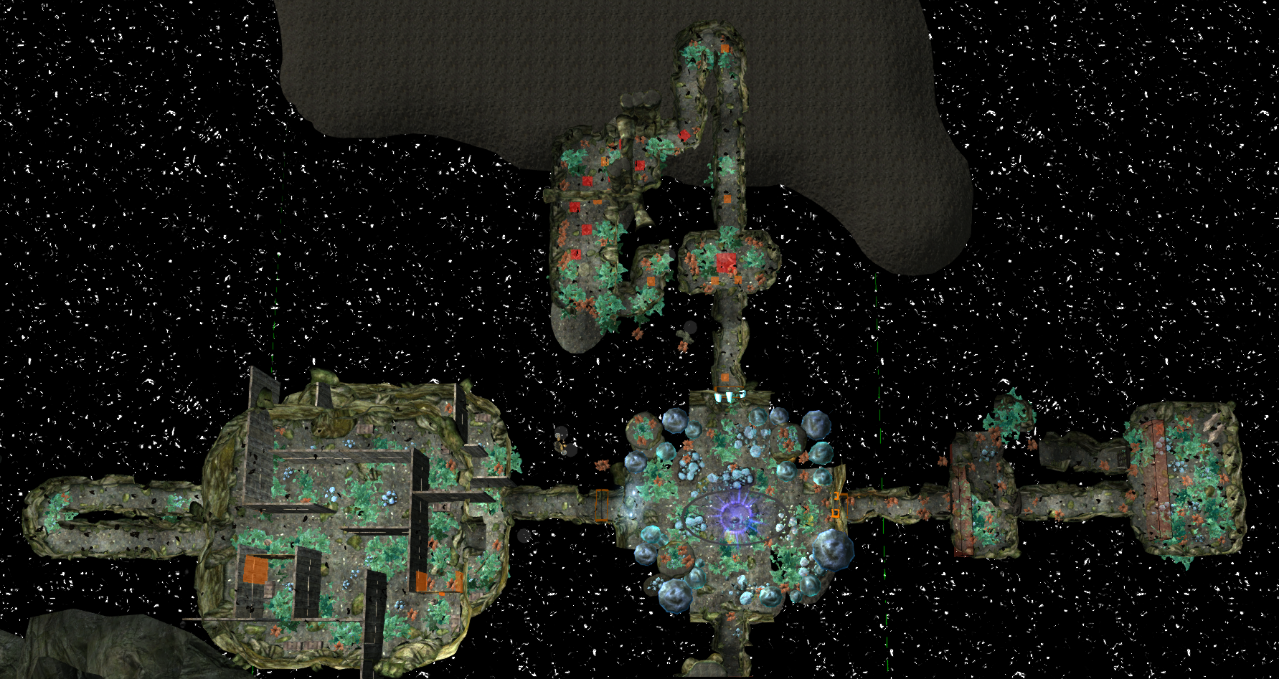
Figure 15: Druid's cave top view (hide second floor)
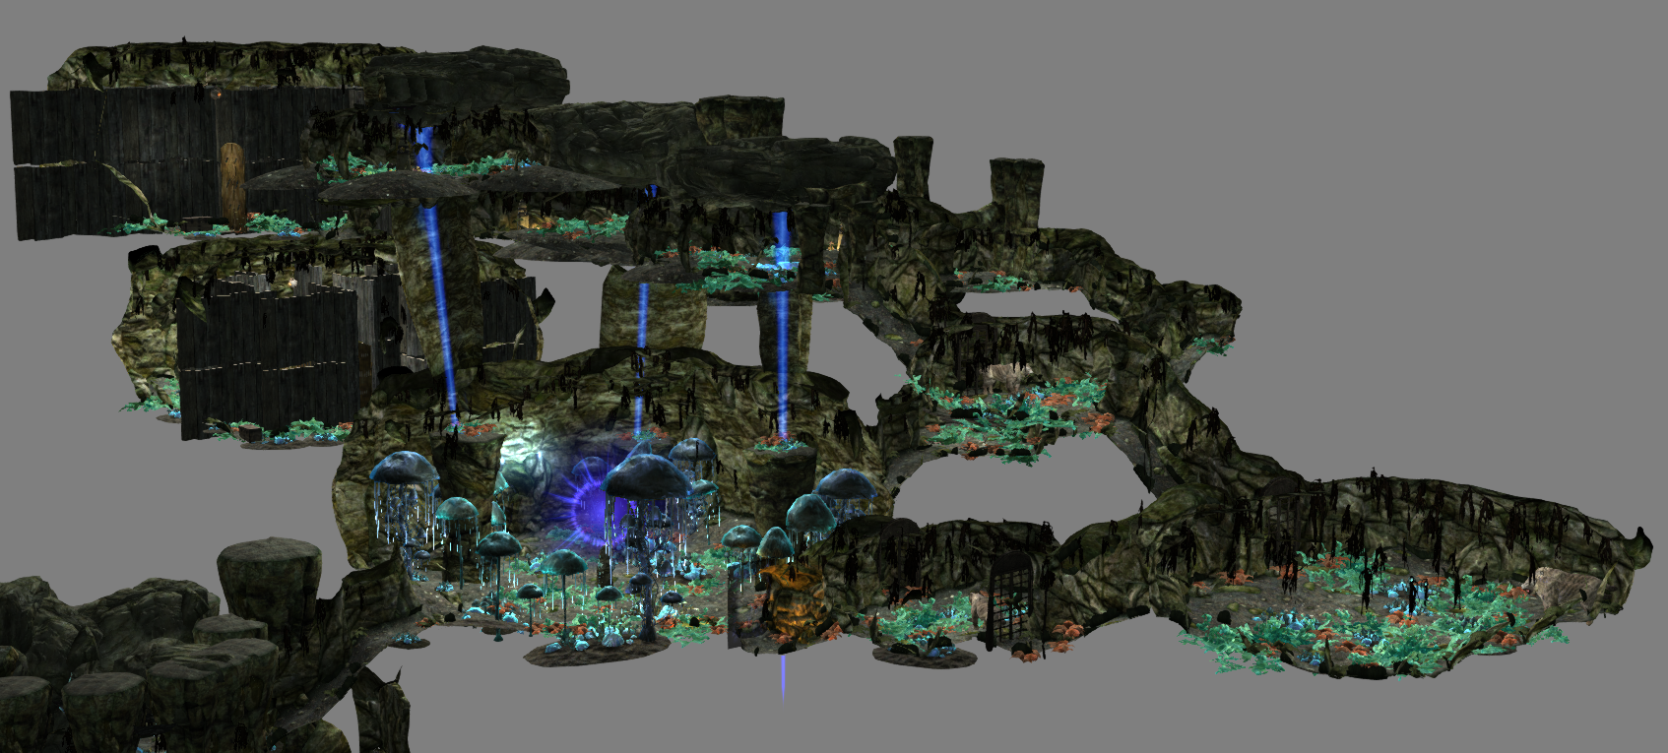
Figure 16: Druid's cave side view
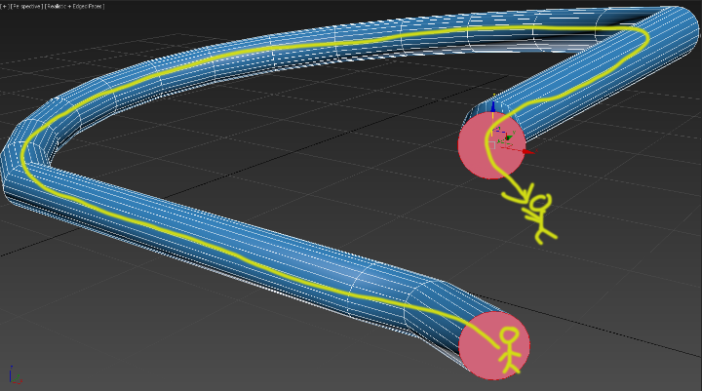
Figure 17: the jump short cut lead the player back to main room (concept)
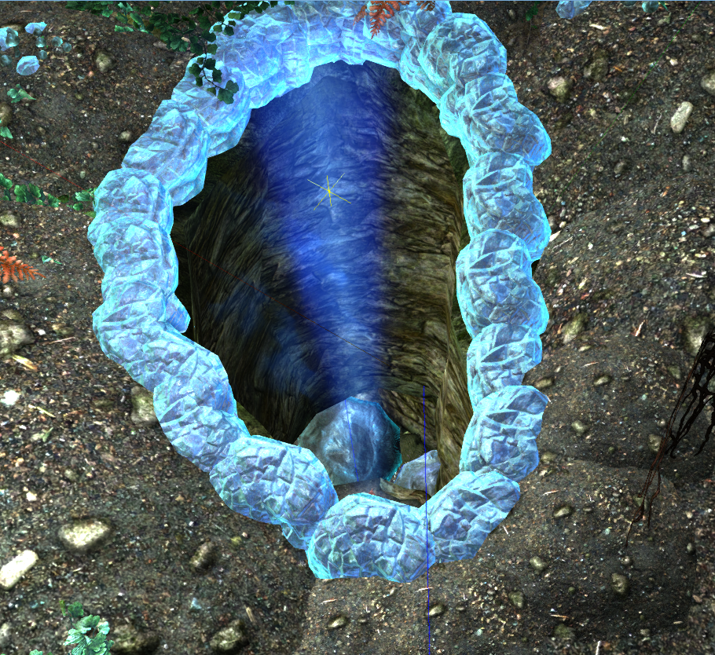
Figure 18: jump short cut screenshot

Level Flow

Flow Summary
- Player sees the stranger (Azuel Fabrith) near the Riverwood Bridge and talks to him to get the brief instruction of what is going on. Then player chooses to start the quest. Azuel tells player he can teleport them to his shanty when the player is ready. Player talks to him again to teleport.
- Player talks to Azuel about what to do next. Player learns about the Druid, Natur the elder, and Azuel needs his soul stone. Azuel tells the player he leaves clues leading the the Druid cave. He also explains he cannot go face the Druid himself because if he dies, no one can save his daughter. Player learns the clues are the glowing balls under the lake.
- (optional) Player accepts the side quest. Player finds and kills the bandit to get the magic key and finish the side quest. The reward is a customized spell book that can teach player to summon three guardians for the player (WOW moment). It can help in the later game.
- Player follows the clue. Player goes through the path under water to get into the cave (WOW moment).
- Player investigates the portal stone and learns he/she cannot use the portal before he/she activates all three rune at the end of three trials.
- Player goes into the trails of wisdom. Answering the riddles of the door to open it and finding the way inside the maze. Player activates one rune at the end of this trial. Player use the short cut (jump hole) to go back to the main cave room (WOW moment).
- Player goes into the trails of caution. Avoiding the traps and fighting the wolf spirits if player trigger the trap. Player activates one rune at the end of this trial. Player use the short cut (jump hole) to go back to the main cave room (WOW moment).
- Player goes into the trails of strength. Killing all saber cat spirits in the room to open the door to next area. Player activates one rune at the end of this trial. Player use the short cut (jump hole) to go back to the main cave room (WOW moment).
- After player activates three runes, the portal is available. Player uses the portal and teleport to the Druid living place.
- Player talks to the Druid, Natur the elder, and gets the information about the options. Player learns that if Azuel finishes his spell, he starts a war eventually. Natur wants to destroy this spell and eliminate the war future. He asks player to help him destroy the spell. Player has two options: kill Natur or help him to destroy Azuel’s spell.
- Player make decisions (branches start)
  - Natur turns into enemy. After a tough fight in Natur’s living place, player kills Natur and brings his soul stone to Azuel. Player talks to Azuel to get the reward. Quest ends.
  - Natur turns into an ally and follows player. Player goes back to Azuel’s shanty with Natur. Player talks to Azuel and tell him the situation. Azuel turns into enemy. After a tough fight in Azuel’s shanty, player kills Azuel with Natur. Player talks to Natur to get the reward. Quest ends.

Level Progression Chart
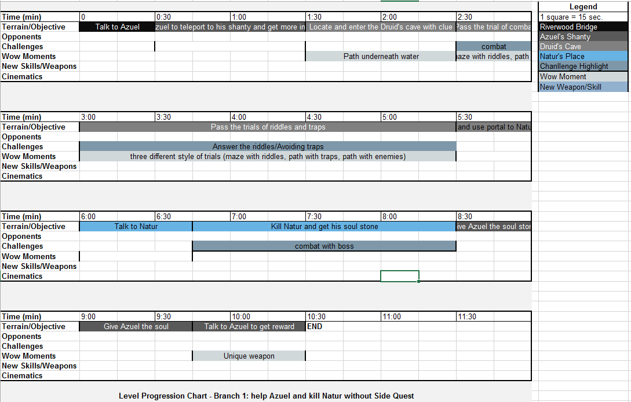
Figure 19: level progression chart

Quest Descriptions

Main Quest – “Eternal Cure”
- Player confronted by NPC, Azuel Fabrith, near Riverwood Bridge (exposition, main character)
- Player receives information on quest from Azuel and learns about the desperate situation of Mabel Fabrith, Azuel’s daughter. Azuel tells the player he can teleport them to his shanty and give player more information. When the player is ready, he/she talks to Azuel to teleport. (dramatic premise/situation)
- Player talks to Azuel in his shanty. He/she learns that the only hope and the cure for Mabel is Azuel’s unfinished spell, which that can turn Mabel into an “undead” but keep her soul “alive”. Player needs to help Azuel get the most important component, the powerful soul of the Druid named Natur the elder. Player needs to find Natur and takes him down for his soul stone. Azuel tells player how to locate the Druid’s cave and the reason why he cannot face the Druid himself. Player also gets the side quest option. (dramatic situation)
- Player goes into the Druid’s cave by following Azuel’s clue (glowing balls leading to the lake). There is a portal stone in the cave. However, while failing to use it, player learns that he/she needs to finish three trials and activate three rune to make the portal work. Player sees three hallways leading to different trials. Player activates the portal by finishing the trials of wisdom (maze with riddles, answer the questions), the trials of caution (path with traps, bear traps can summon the wolf spirits) and the trial of strength (path with combat, kill saber cat spirits to unlock the door). Player goes through the portal to meet Natur. (obstacles)
- Player talks to Natur, surprising that Natur was waiting for the player. Natur shows player he already knows what is going on. He tells player that Azuel cannot finish his spell and why. He asks player to help him destroy the spell. Player needs to make a decision. One option is to continue helping Azuel and kill Natur, the other option is to follow the advice of Natur and destroy the spell, even that means they have to kill Azuel. (dramatic situation/ inciting incident /first culmination)
  - Branch 1: player tells Natur their decision is to continue helping Azuel. (Climax)
    - Player kills Natur to get his soul stone. (Climax)
    - Player returns to Azuel with Natur’s soul stone. With the player help, Azuel gets Natur’s soul stone and successfully saves his daughter. (falling action/denouement)
    - Player collects the reward of a customized magic weapon that can absorb stamina while attacking. Player finishes the quest. (denouement)
  - Branch 2: Player tells Natur their decision is to stop Azuel from finishing the spell and agrees to help him. (Climax)
    - Player goes back to Azuel’s shanty with Natur. (Climax)
    - Player talks to Azuel and tries to convince him to destroy his spell. Azuel rejects immediately and becomes furious. A deadly fight is unavoidable. (Climax)
    - Player kills Azuel. (Climax)
    - Natur rewards the player with a unique spell that can summon three powerful guardians (flame thrall, frost thrall, and storm thrall). Player finishes the quest. (falling action/denouement)

Side Quest – “Help from the Ancient”
- Player gets the information from Azuel that he has a spell book may help the player fight the Druid. He locked it inside of a magic chest. However, the bandits took the chest away along with the key. Azuel tells player the bandit burned down his house, which is reason why his shanty looks like ruins. He also tells player why he cannot deal with bandits himself. Because he was worried about if he went and fought bandits, some of them might sneak into his shanty and kill his daughter. Player gets the location of the bandit camp location. (dramatic premise/situation)
- Player locates the bandit camp near Azuel’s shanty. (dramatic situation)
- Player kills bandit chief and gets the key. Player finds the chest in the camp. (Climax)
- Player opens the chest and gets the spell book. Player learns the spell to summon three wolf spirits that fights for the player. The side quest ends. (falling action/denouement)

References

[1] https://heavenawaits.files.wordpress.com/2009/06/angel-grief.jpg
[2]https://www.google.com/search?q=dead+land&newwindow=1&espv=2&biw=1920&bih=955&source=lnms&tbm=isch&sa=X&ved=0CAYQ_AUoAWoVChMIjN3z6r7yyAIVTeZjCh2h2AVD#newwindow=1&tbm=isch&q=mage+house+inside&imgrc=2WrOtJfwhUMEbM%3A
[3]http://vignette2.wikia.nocookie.net/witcher/images/f/f1/Places_Druids_cave.png/revision/latest?cb=20081116175836
[4] https://chriscaff.files.wordpress.com/2011/10/temple8.jpg
[5]http://vignette2.wikia.nocookie.net/witcher/images/f/f1/Places_Druids_cave.png/revision/latest?cb=20081116175836
[6] http://www.historvius.com/images/original/Belchite-1296.jpg
[7] https://elephantsabout.files.wordpress.com/2012/02/dsc03309.jpg
[8] http://www.democraticvistas.net/images/9/91/Deadland.jpg
[9] http://static-2.nexusmods.com/15/mods/110/images/49484-3-1388757495.png
[10] http://static-2.nexusmods.com/15/mods/110/images/49484-1-1388757494.png

